**COMPARISON OF DETROIT HOMICIDE AND CARJACKING LOCATIONS**

**Introduction**

**Background:** Detroit is a city of more than 670,000 people, and known to many as the global capital of the auto industry. Like any other social center, it has its share of problems and challenges while running a city of this size and financial magnitude. One particular area that the governance has to tackle is crime and the law enforcement needs all the tools to curb it. Although crimes are of many categories, violent crimes take the higher priority to be solved and be prevented for the overall well-being of the society. Homicide and carjacking are two such categories. Carjacking is especially relevant to Detroit due to the large auto industry. The key aspect that this analysis targets is whether there is a correlation between the neighborhoods of carjackings and homicides. Such a correlation would help to identify crime patterns which are crucial for preventive campaigns.

**Problem:** Data required for this problem is the Detroit police department current record for confirmed carjacking victims and confirmed homicide victims. The features include crime locations (coordinates), along with respective precincts, date & time, etc. Along with DPD data, foursquare API would be used to get data on the neighborhoods of these crimes to gather the common venues. This project aims to find any correlations between crime neighborhoods of the two different categories and present likely places that probable for these incidents by analysis of common location clusters.

**Interest:** The analysis would be of particular interest to Detroit police department (which is at the front end of crime fighting) as well as the city council which takes measures for the long term and policy measures for rectification of such issues.

**Data acquisition and cleaning**

**Sources:** DPD website provides data for all of its crime categories. The relevant data required for this problem was for the confirmed homicide victims and for confirmed carjacking victims. The two data sets provide location data for the victims of respective categories. In order to gather the data for nearby venues / neighborhoods, foursquare API was used (/venues/explore).

**Data cleaning and wrangling:** Data cleaning includedmissingvalues from different fields which were dropped to keep continuity in the data. Since the data ultimately is going to be used for a categorical problem, mean values were not used.

Moreover, upon examination, the coordinates data had large chunk of repetitive values (exact same values). Although the corresponding data fields did cover some varying data which showed that these were different instances, the duplicate coordinate values were unusable and therefore dropped.

Date and time formats had to be changed and converted to pandas to.datetime format for better utilization in visuals. Multiple repetitive values in different features had to be formatted using regexs e.g day column.

To apply K-Means for clustering, the venues data from foursquare API was converted into one hot vectors for individual categories and then joined with coordinates as the index.

For further analysis of the clusters, cluster coefficients were added to the data and another data frame was created with the first 10 most common places against each location.

**Feature selection:** The core features used included location coordinates, date, time, precinct, day of the week. Other fields such as report number, object id, state etc. which had little relevance were dropped. Also, fields such as address and zip codes, which were in effect repetitions were also dropped. In addition to the features of DPD data, venue features were added using foursquare API. By creating one hot vectors for different categories of venues, 258 additional feature columns were created.

**Exploratory Data Analysis**

Initial data analysis revealed some similarities and differences between homicide and carjacking data. Since the over all area under consideration for both the crimes is the same, police precincts were also the same. Shown below are the distributions of cases received precinct vise for carjacking and homicides respectively:

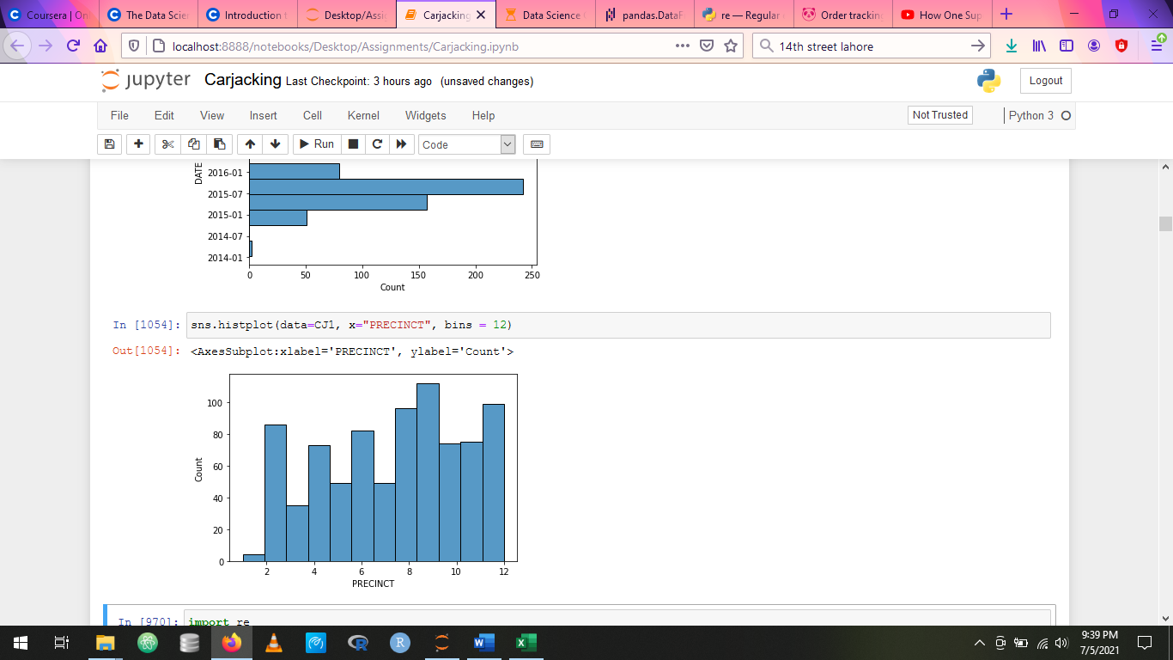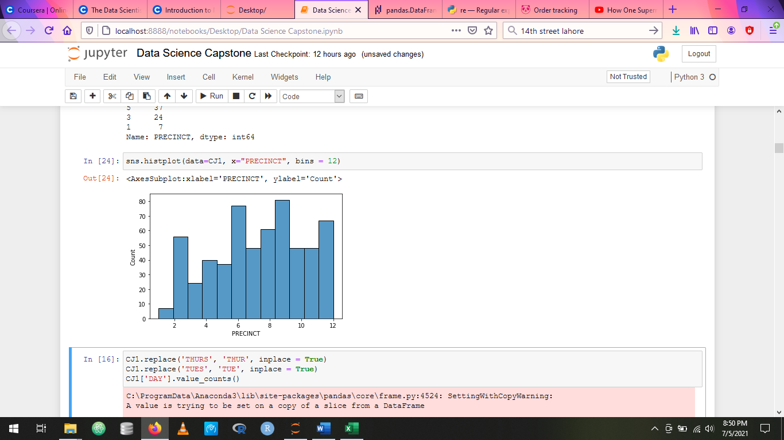

**Carjacking Homicide**

Notice that overall pattern for both remained the same, with precinct 9 having the highest crime rate for both categories, there were minor differences e.g precinct 6 being significantly higher in homicide percentage and ranking than in carjackings.

Occurrences vs date distributions are shown below. Not much can be derived from the data except that there is some data missing which caused gaps in the periods shown.

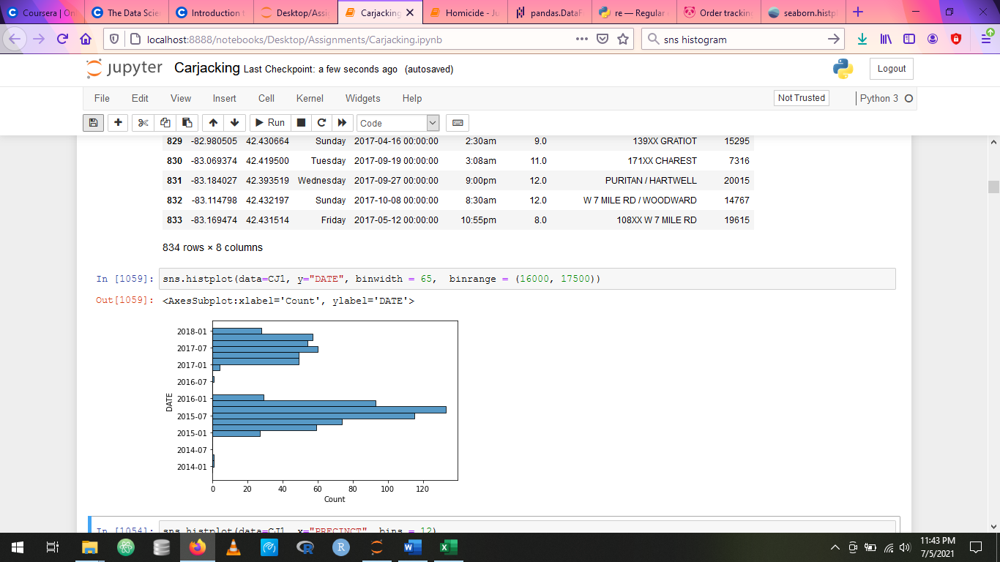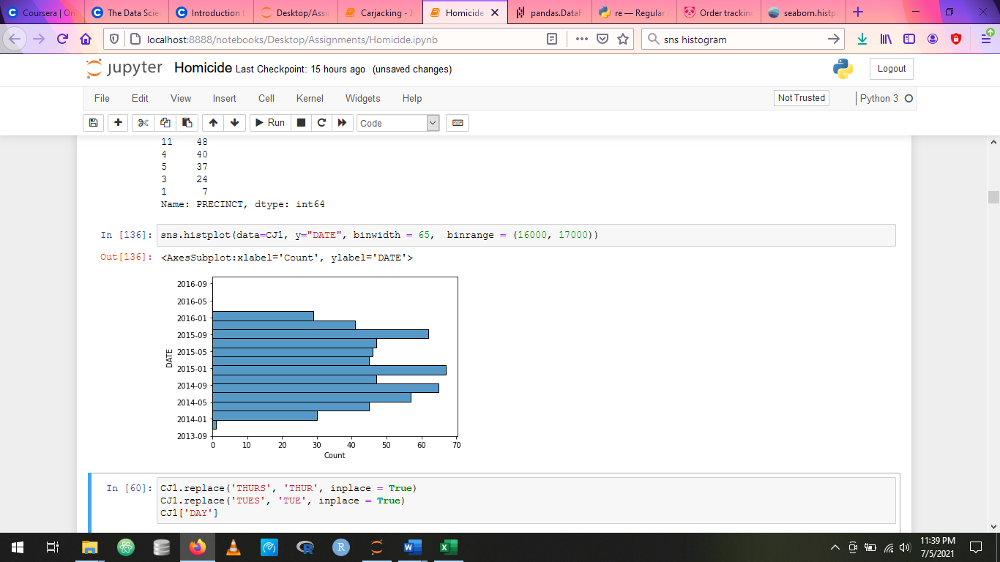

**Carjacking Homicide**

Occurrences vs time distributions had some important insights. For the carjacking data, the distribution shows heightened crime activity during small hours i.e during the dark and less activity during mid-day, noon, which makes sense. On the other hand, for the homicides, the data was missing anti meridian / post meridian (AM / PM) which led to reduced insight. The overall pattern seemed similar to carjacking albeit there was room for error due to the above mention fact.

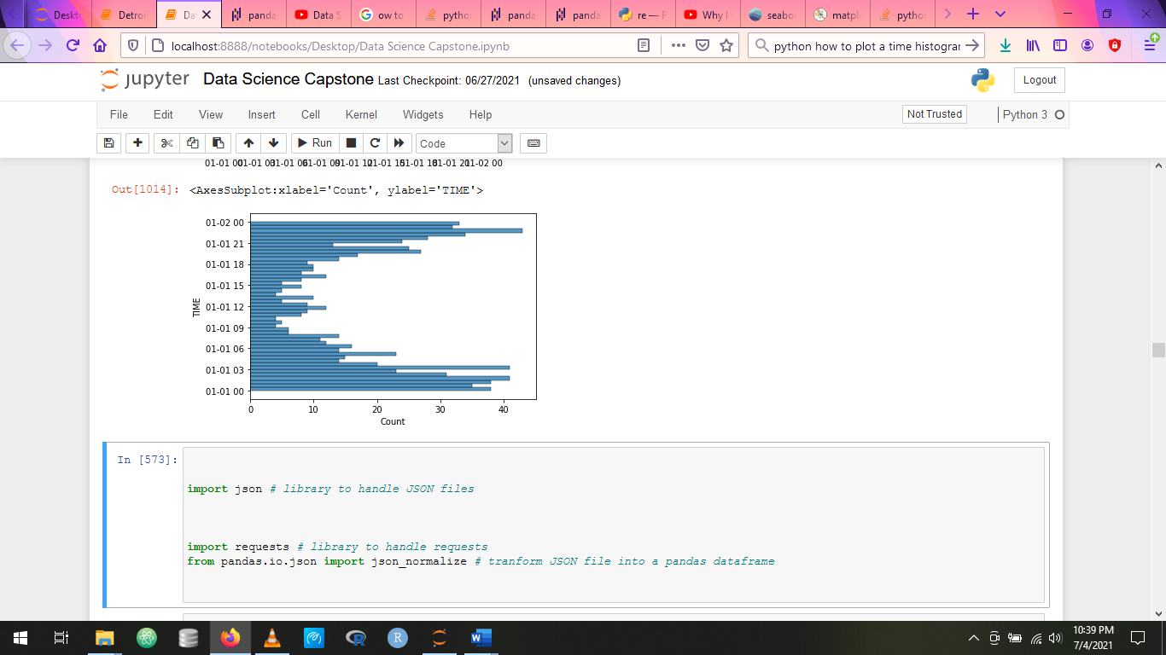 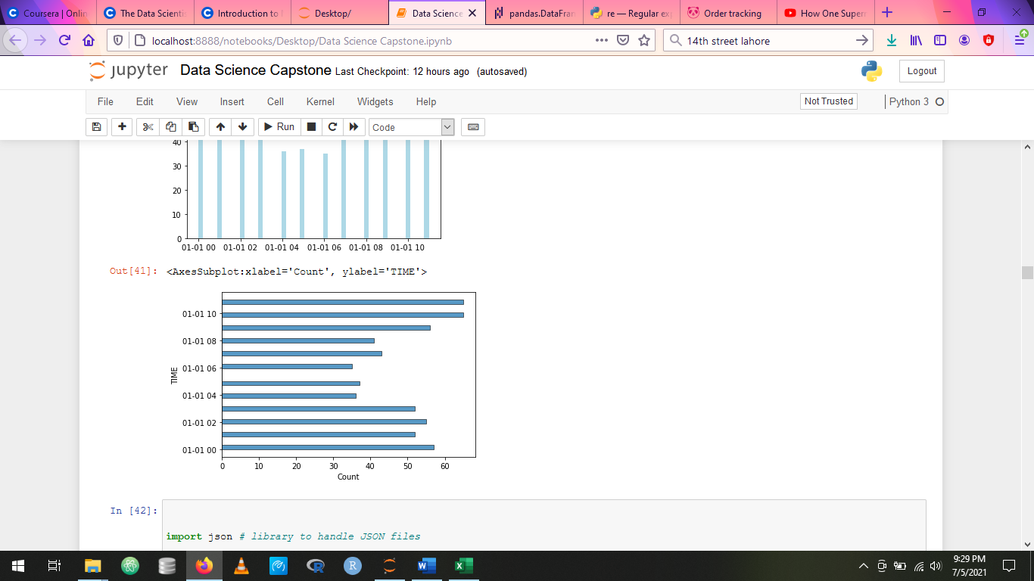

**Carjacking Homicide**

Day vise occupancies are shown below. Weekends show heightened activity for both, however for homicides, just the days before and after weekends are also important i.e Monday and Thursday.

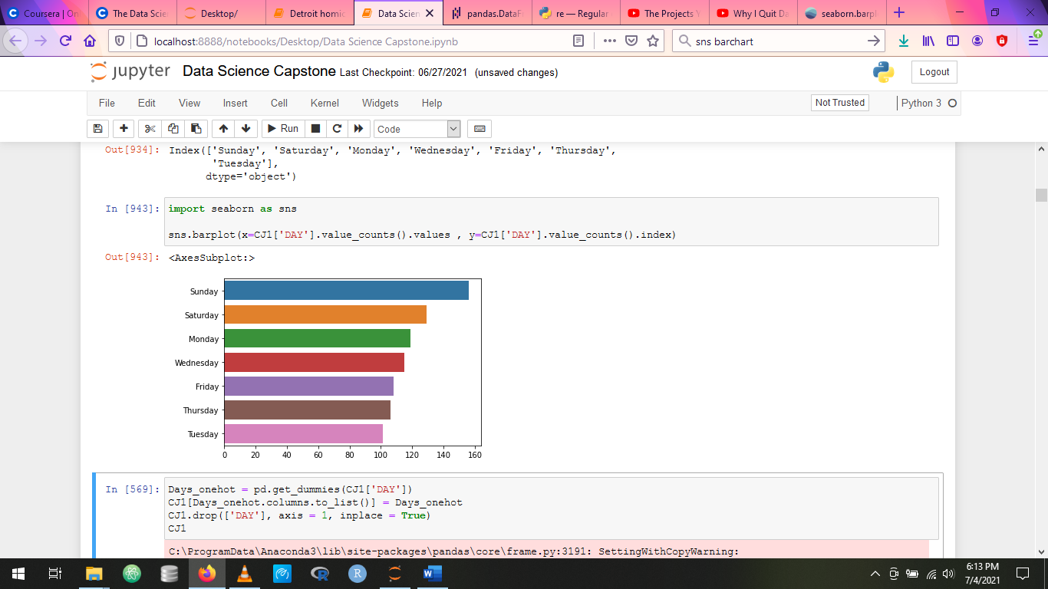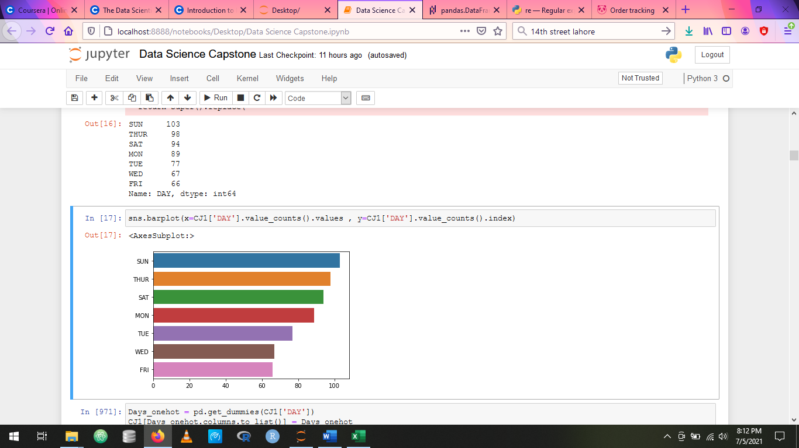

**Carjacking Homicide**

Finally, venues data that was gathered from foursquare api was sorted into most common venues in hierarchical order. The distributions showed that both crime categories had common locations for occurrences. However, the distinguishing features were that liquor stores and bar were much more common (the most common) in fact for homicide victims whereas for carjacking victims’ restaurants and coffee places etc were more common. Another important observation was that although ATMs were common for both crime categories, they were more common for homicide locations.

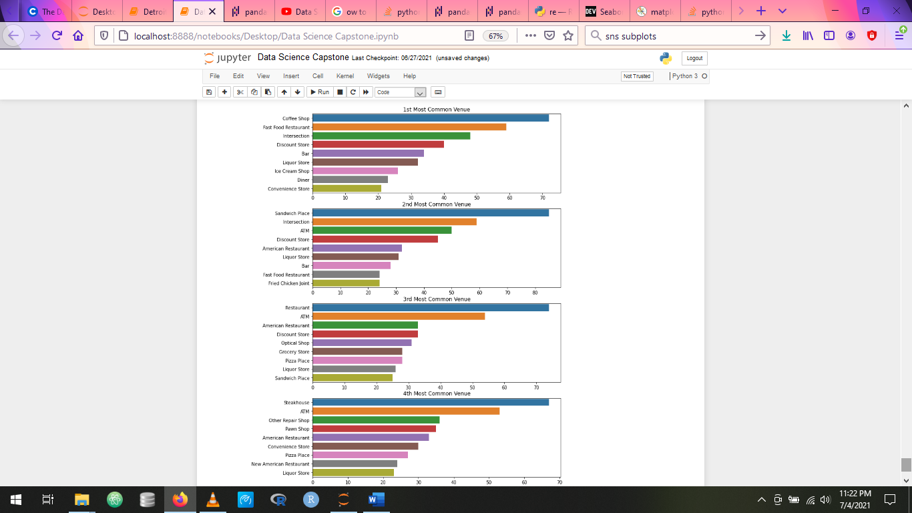

**Carjacking**

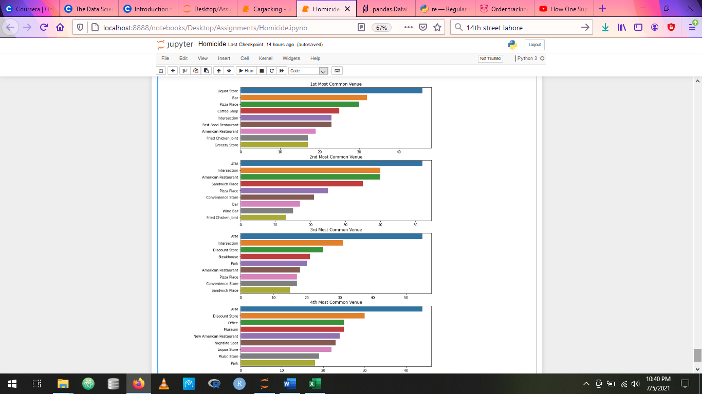

**Homicide**

**Applying the Model**

**Clustering:** Since we are interested in the nature of the locations where the crimes were committed and finding out patterns and correlations, **K-means clustering** was used to develop clusters of locations in order to group similar occurrences together. From there on the cluster labels were used to plot the incidents on map using folium:

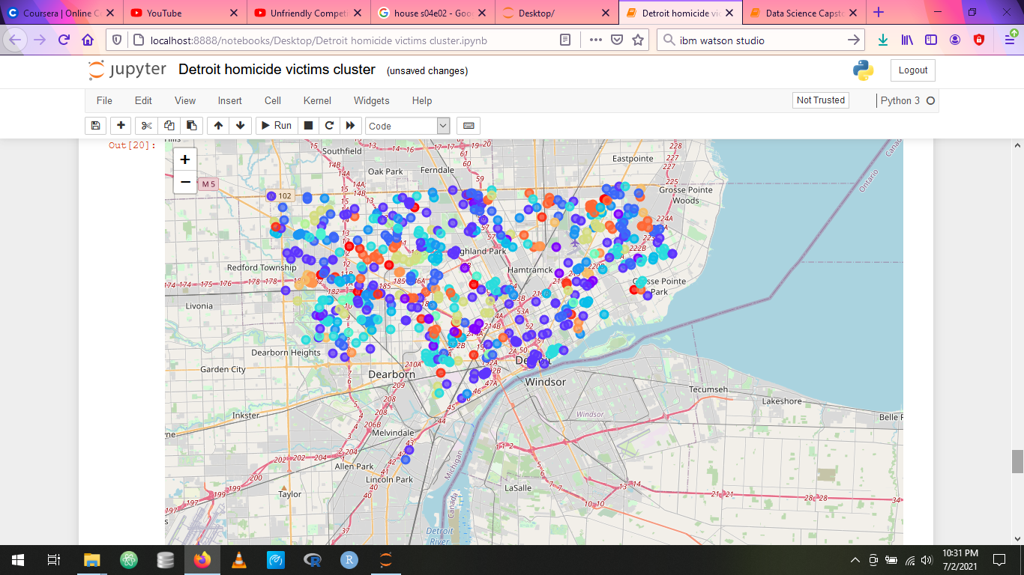

While applying the clustering models, cluster size of **16** was maintained for all “settings”. This is because this size generally provided clear and concise cluster bifurcations with healthy and consistent cluster sizes (for this particular dataset(s)). Features such as day, date and precinct were initially used for the models, however these provided for unwanted bias and were therefore dropped subsequently. This is not to say that no meaningful insights were derived from such clusters. A couple of examples are shown below:

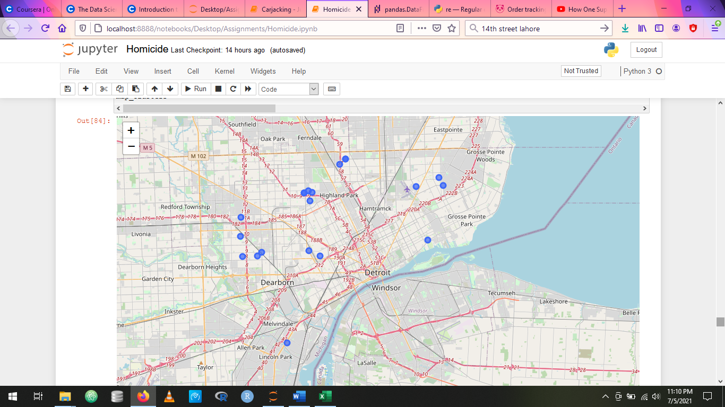

**Homicide locations on a Sunday near liquor stores**

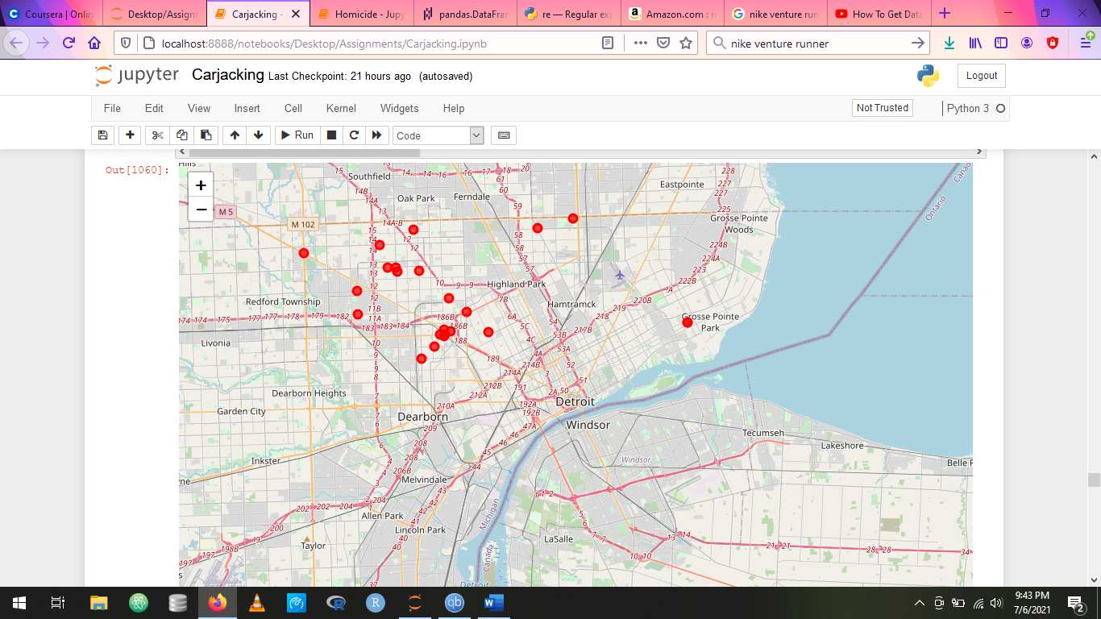

**Carjacking locations on a Sunday near Gas stations**

Ultimately the challenge was that the data was less in size to fully exploit the potential of these features in forming meaningful clusters. Comparison of clustering with only venues data is shown below:

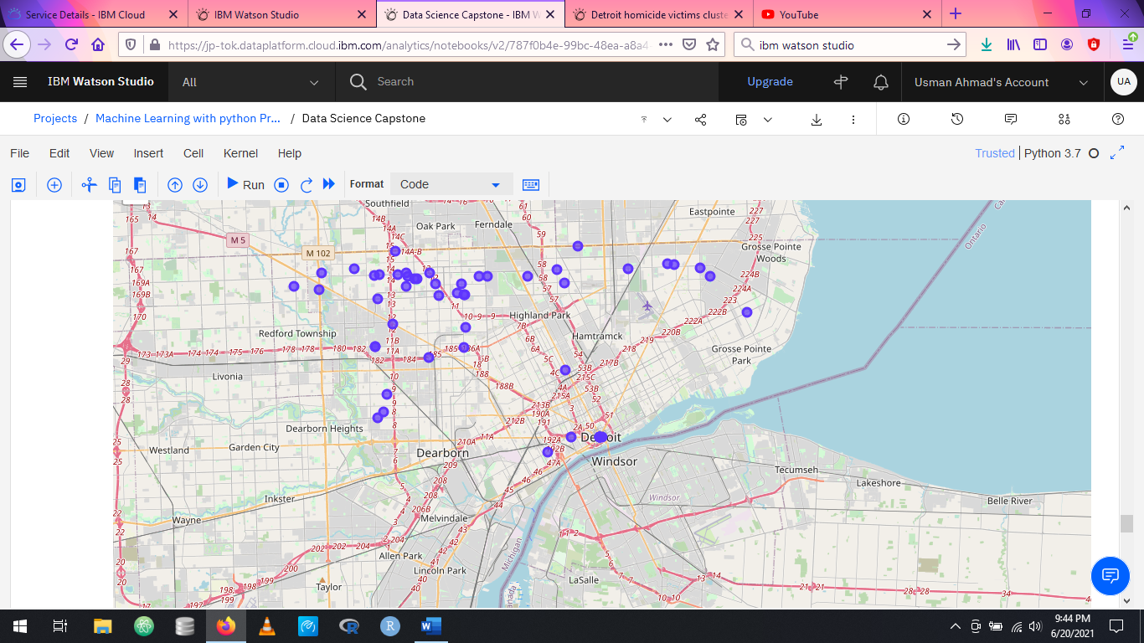 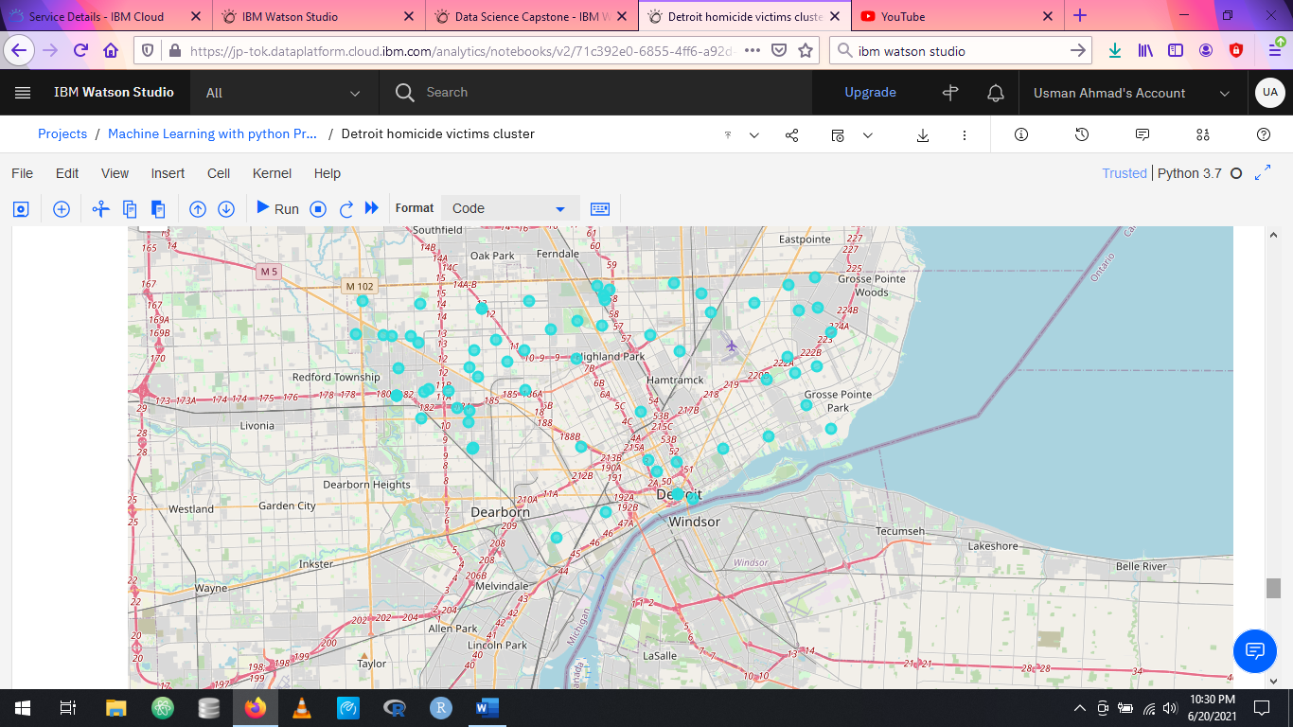

**Carjackings near liquor store Homicides near liquor stores**

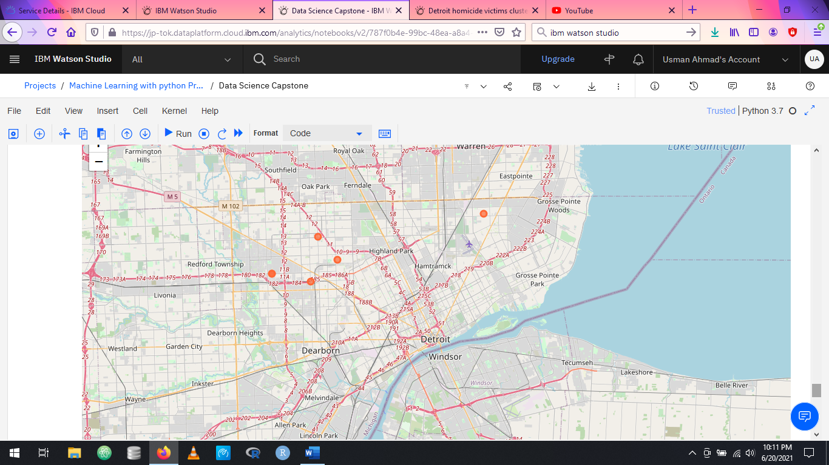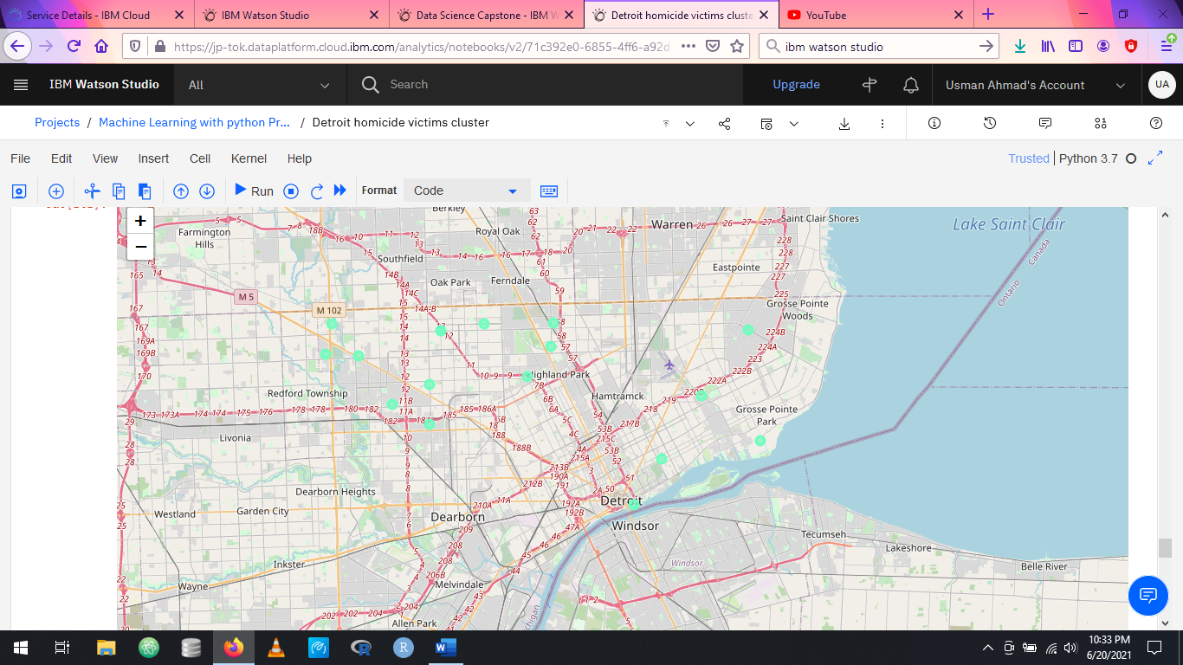**Carjackings near construction sites Homicides near construction sites**

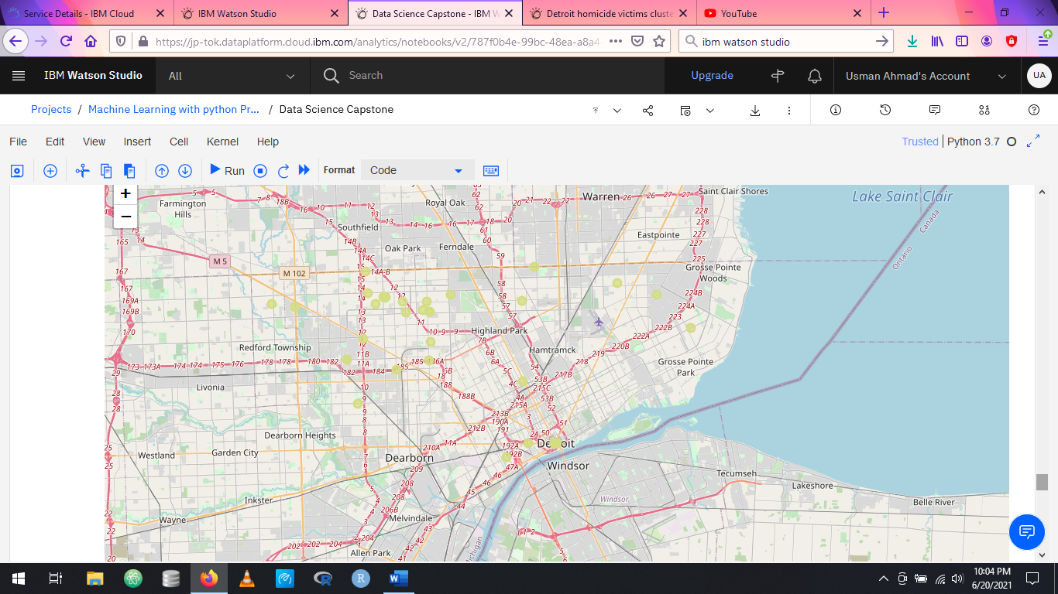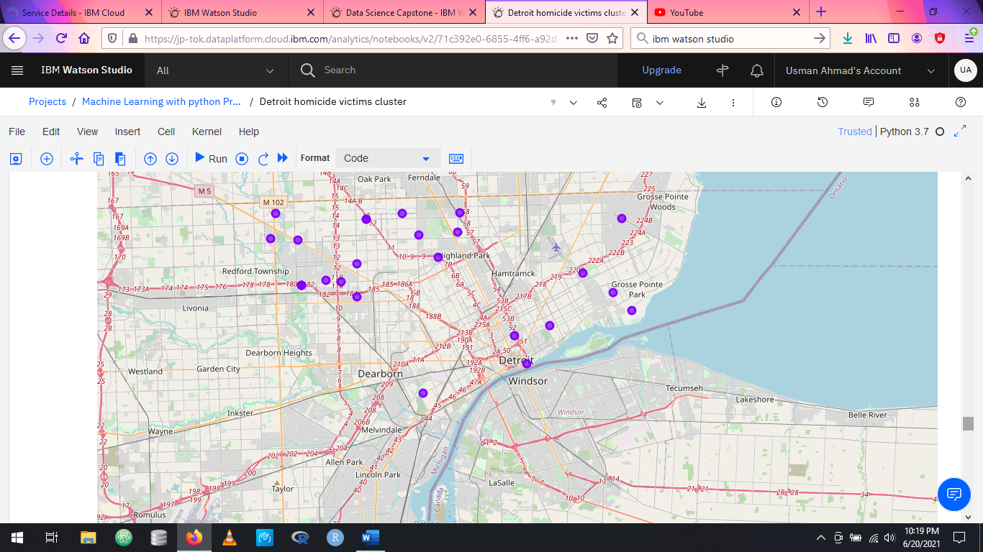

**Carjackings near Conv stores Homicides near Conv stores**

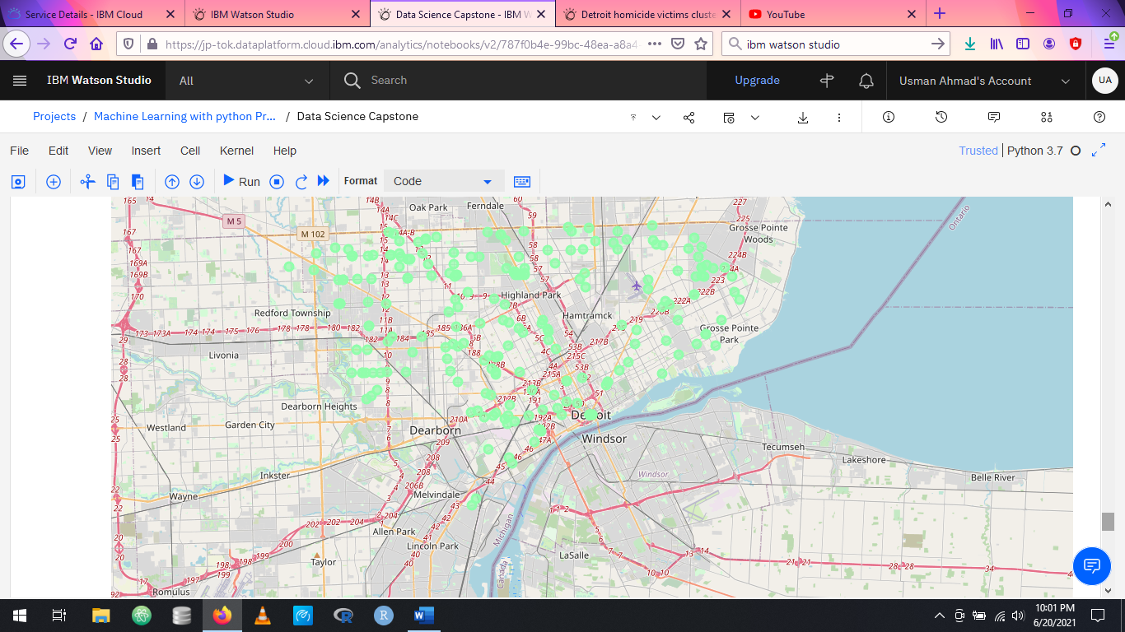 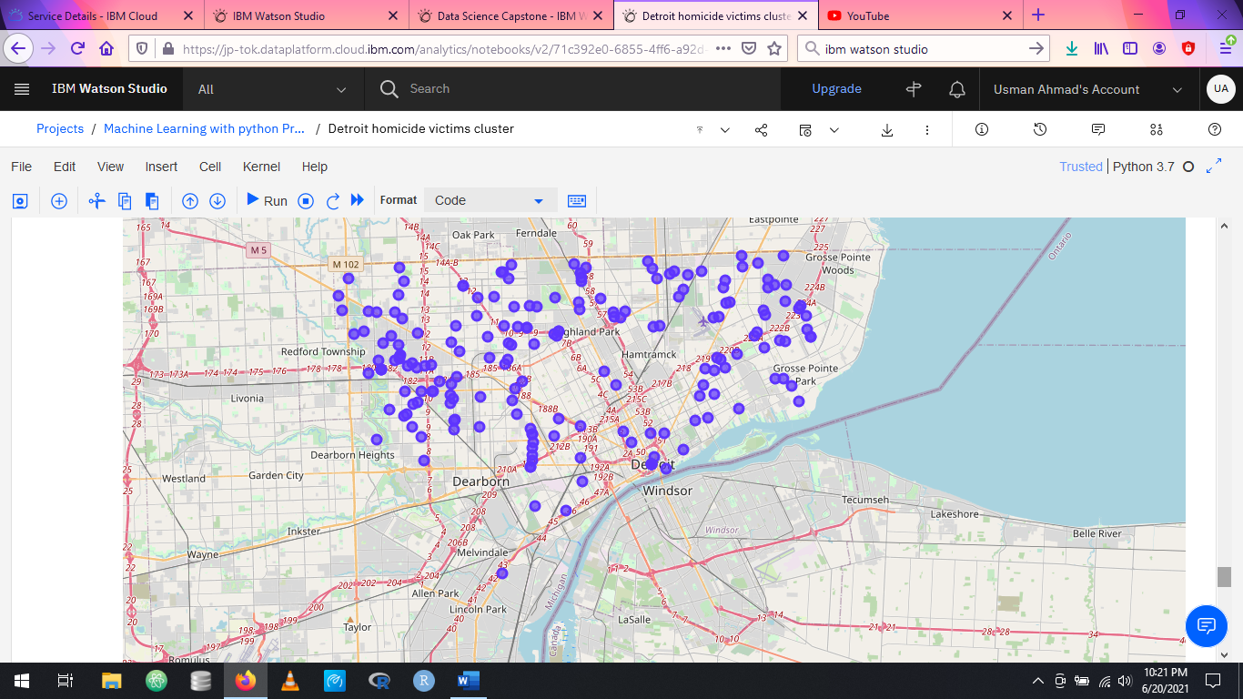

**Carjackings near Homicides near**

**diner / coffee / sandwich place diner / coffee / sandwich place**

The crime locations when plotted on the map show similar distributions for different venues, crime being the highest in west Detroit, followed by east Detroit and the least in south Detroit regions. The distributions also show that carjackings tend to be higher (as compared to homicides) near food places etc.

**Conclusions**

The results show that carjackings and homicides do have some common / overlapping locations, however more carjackings tend to happen around restaurants and fast-food places than homicides, probably due the absence of victims from their cars providing for good conditions for car jackings. On the other hand, more homicides were committed close to liquor stores, bars / wine bars etc. this suggests that alcohol consumption may be a reason for the crime being committed (either by the offender or the victim). ATMs were also more commonly found near homicide incidents.

**Future directions**

For future directions, deeper and more specified comparisons between the two offences may be carried out. For example, the data used was missing sex data for the victims which would have been insightful for identifying the patterns for the locations of victims for men and women especially in the case of homicide victims. Likewise, data for the offenders would also be very useful for creating better clusters and hotspots for these crimes which includes sex data and in particular the primary reason for the crime being committed (more son in the case of homicides).

Although foursquare API provided good data for the venues in the vicinity, additional data which provides economic, social and educational indicators along with chronological data for the particular neighborhoods would be very useful to come to a better conclusion in understanding the cause and pattern for these crimes which is ultimately crucial for any effort to reduce or curb trends in crime for a region.